Capstone Task Day 02
Name: Ibrahim Shnouda
Group: IoT701-A
Facilitator: Eng.Ehab Elsayed
------------------------------------------------------------------------------------------------------

Tasks:

1.~/iot_logger/logs $ touch temperature.log
~/iot_logger/scripts $ touch sensor_script.py

2.~/iot_logger/data $ sudo cp /etc/services ./ && grep -Ei '(ssh | http)' services

3.~/iot_logger/data $ grep -E '(^t| [0-9])' services

4.~/iot_logger/data $ find /home/ibrahim/ -type f -name "*.txt"

5.~/iot_logger/logs $ ln temperature.log temperature_hard.log
~/iot_logger/logs $ ln -s temperature.log temperature_soft.log

6.~/iot_logger $ tree

-------screenshot---------

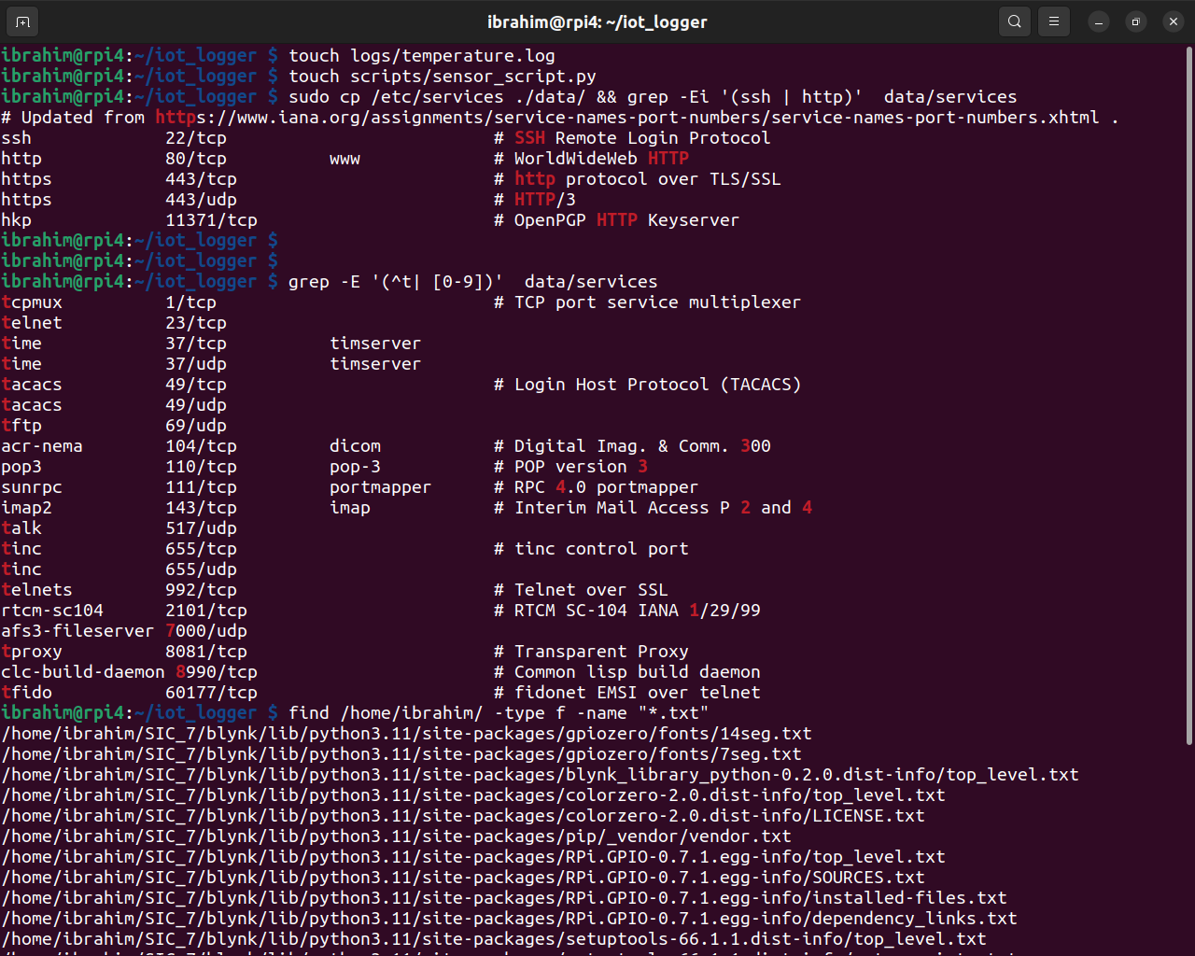
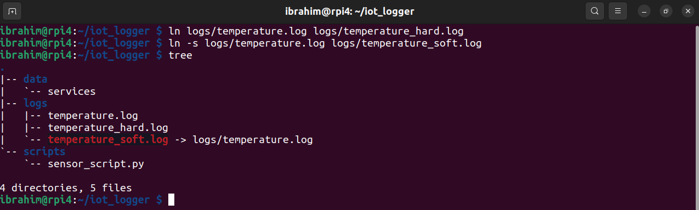

Open-Ended Questions:

1. File types:
1.1. Regular File: .txt,. bin , .jpg, and .out files starts with (-) in file permissions like this file : -rw-r—r--

1.2. Directory: special type of files stores files or directories starts with (d) in file permissions like this file : drwxr-xr-x

1.3. Symbolic link: it is similar to a shortcut to file of directory tarts with (l) in file permissions like this file : lrwxrwxrwx

1.4. character device file: refer to device deals with stream data like keyboard starts with (c) in file permissions like this file : crw-rw-rw-

2.Hard link vs Soft link:
2.1. Hard link: give a file second name to the same data
(new pointer to the same data)
uses in backup without more disk usage

2.2. Soft link: is like a shortcut to file or directory
uses to organize data.

3. rmdir vs rm -r
3.1. rmdir: remove only empty directories.
3.2. rm -r: remove all directories even not empty with files or subdirectories

Thank You….

